Social Prescribing to promote and improve access to health and care services for people in vulnerable situations in Europe
SP-EU
#@APP-FORM-HERIAIA1ST@# #@REL-EVA-RE@#

Excellence

Objectives and ambition #@PRJ-OBJ-PO@#
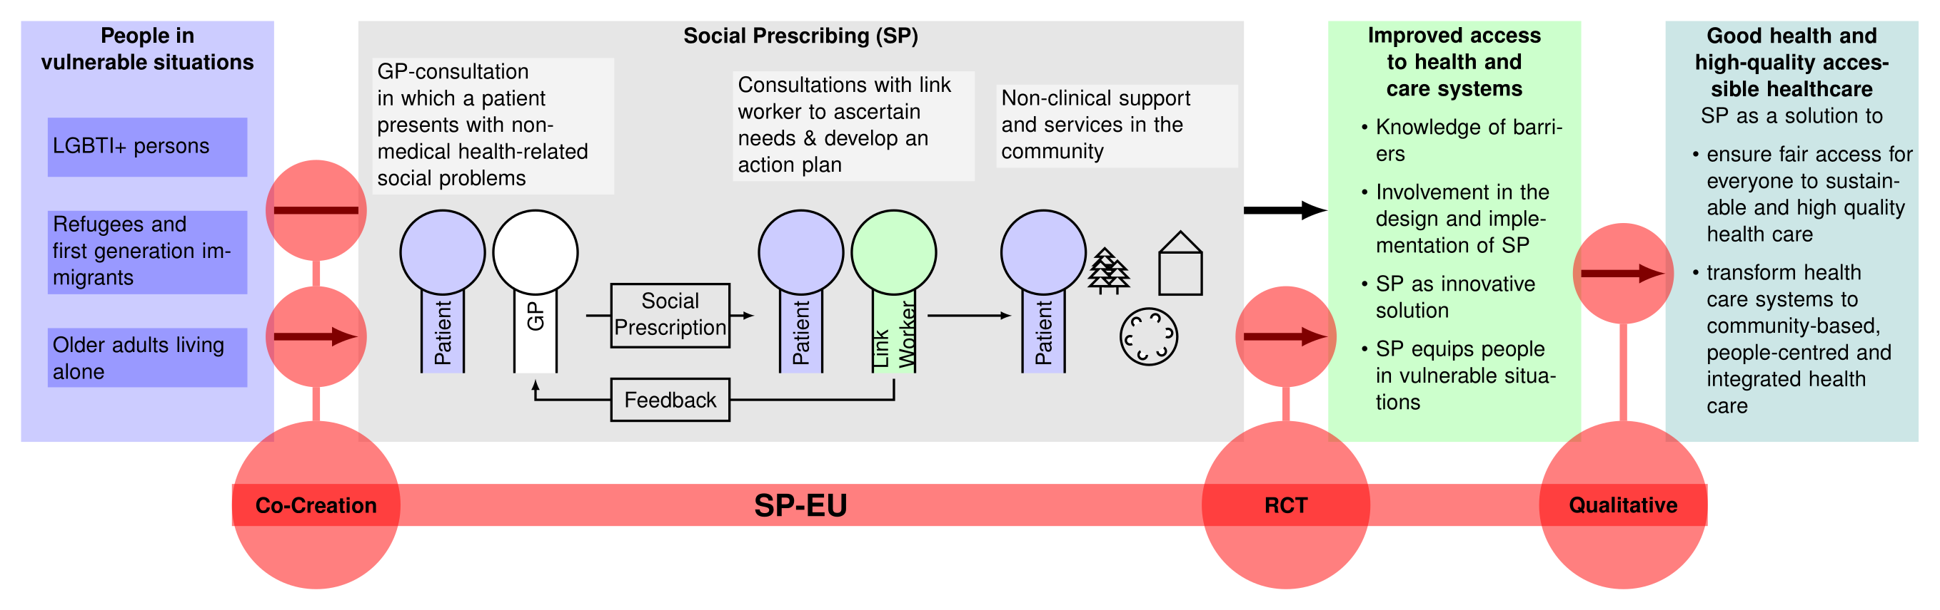 People in vulnerable situations have a lower chance to achieve good health. One reason for these unequally distributed chances for good health are health-related social problems, such as loneliness, housing problems, financial problems of problems in the family. Social problems can increase the risk for diseases, lower quality of life and impair health as a state of complete physical, mental and social well-being.
In the European Union, to cover these unmet social needs, there are many non-clinical supports and services within the community available such as voluntary organisations, NGOs and counselling services. However, these offers usually do have no connection to the health care sector and people in vulnerable situations often underutilize these services. The first point of contact for people with social problems is often the general practitioner’s (GP) office, because social problems often manifest themselves somatically or people simply do not know where to go. However, due to this dis-integration of health and care services, widely existing third sector offers in the community are not adequately accessed.
Social Prescribing (SP) is an innovative solution to bridge this gap, improve access to health and care services and strengthen the community orientation of health care. SP enables GPs to issue a social prescription for patients with health-related social problems. Subsequently, these patients have several appointments with a so-called link worker. The link worker provides personalised support and focuses on what matters to the person. Together with the patient, they create an action plan and help them access community resources by addressing any barriers that may exist.
There is already some evidence that social prescribing has positive impacts. Subsequently, SP has been rolled out nationwide in the UK. Several European countries have taken up the idea of social prescribing to differing extent, between no uptakes to planning to roll it out nationwide. However, SP has not been tailored to the needs of people in vulnerable situations and the effectiveness of SP to improve access to health and care services for people in vulnerable situations is unknown yet. Thus, it is of utmost importance to tailor SP specifically to people in vulnerable situations, prove the effectiveness of SP for vulnerable groups and to provide evidence for the sustainable implementation of SP.
Objectives
Our vision is that Social Prescribing improves access to health and care services for people in vulnerable situations and thus contributes as a scalable and transferable innovative solution to the transformation of health care systems towards community-based, people-centred and integrated health care.
The overall objective of SP-EU is to assess the potential of social prescribing to promote and improve access to health and care services (in a broader notion) for people in vulnerable situations, focusing exemplary on a) LGBTIQ persons, b) refugees and first-generation immigrants and c) older adults living alone. Our ambition is defined by five major objectives:
Objective 1 is to involve people in vulnerable situations belonging to these three groups in the design and implementation of social prescribing adapted to their needs and social context.
KPI 1.1a-c) Three co-creation workshops with each group a)-c) in 12 months.
KPI 1.2) Publish a manual on co-creation in European health care interventions
KPI 1.3a-c) One co-creative interpretation workshop with each group a)-c) until the end of 2029.

Objective 2 is to assess the effectiveness of social prescribing to improve access to health and care services for a) LGBTIQ persons b) refugees and first-generation immigrants and c) older adults living alone by a pragmatic international multicentre randomized controlled basket trial
KPI 2.1 a-c) Randomize at least 600 primary care patients from at least six European countries in an RCT on the effectiveness of social prescribing until the end of 2027
KPI 2.2 a-c) Complete a 6-month follow up assessing the primary endpoint of at least 400 participants until mid-2028
KPI 2.3 a-c) Publish one article on intention-to-treat analysis of the primary endpoint as a preprint until XXX
KPI 2.4 Publish one article on the meta-analysis to pool the data of all three sub-trials as a preprint
KPI 2.5 Publish one article on the health economic analysis as a preprint
KPI 2.6 Publish all pseudonymized trial data

Objective 3 is to explore enabling and disabling factors to implement social prescribing as a measure to improve access to health and care services for people in vulnerable situations as a scalable and transferable solution for different European countries.
KPI 3.1 Conduct 100 qualitative interviews with stakeholders in five European countries
KPI 3.2 Publish one article on framework analysis to assess enabling and disabling factors

Objective 4 is to inform and discuss with decision- and policy makers, providers and health and care workers the potential impact of social prescribing on good health and high-quality accessible healthcare based on our findings.
KPI 4.1 Conduct five workshops for decision- and policy makers in Europe on social prescribing
KPI 4.2 Conduct one workshop in each European country involved for providers and health and care workers how to implement social prescribing for people in vulnerable situations.

Objective 5 is to inform the public society about the potential of social prescribing and the results of our study continuously.
KPI 5.1 Communication via social media channels with at least 1,000 followers to discuss our project with the public until the end of 2026.
KPI 5.2 Communication via classic mass media in at least six countries will mention our project at least twice over the five-year project timeline, e.g., breakfast television

Progress beyond the state-of-the-art and ambition
We propose SP as an innovative solution to promote and improve access to health and care services for persons in vulnerable situations, more precisely the different groups of vulnerable persons.
While there is quite some evidence on the positive effects of SP in the general population, there is a lack of rigorous conducted RCTs to prove effectiveness. Most studies so far have been conducted in the UK. There has been no multinational trial to prove the effectiveness of SP so far. Thus, this first multinational trial on social prescribing will be ground-breaking in researching a care intervention being tested in different European health care systems on primary care level. This is going to be one of the largest European RCTs on primary care level looking at health care interventions ever conducted.
- Additionally, there have been no thoroughly conducted adaptations of SP to the needs of vulnerable groups. If SP has beneficial effects for people in vulnerable situations has not been tested yet. The international co-creation process will be highly innovative in adapting existing co-creation processes to multinational studies and thus exemplary for the future.
Thirdly, while there is quite some knowledge on implementing SP in the UK, there have been only very few studies looking on SP in Europe beyond the UK. SP-EU will contribute to widening the existing state of the art looking at implementation processes in different European health care systems comparatively and thereby XXX.
Positioning of the project on the innovation chain (‘from lab to market’ or ‘from idea to application’)
The project starts at Technology Readiness Level 6. The feasibility and positive effects of SP in the primary care setting and the community, as well as for the population in general have been shown in the UK. However, there is a lack of evidence on the feasibility and effectiveness for people in vulnerable situations, as it is known that these three groups are underserved in current SP programs. In addition, there is only very limited evidence for the effectiveness of SP outside the UK. With this project including co-creation, pragmatic RCT and qualitative implementation research, we will bring SP to Technology Readiness Level 9 by making SP for people in vulnerable situations widely available in Europe with the necessary evidence to convince relevant policy makers and funders to integrate the concept into usual care.
#§PRJ-OBJ-PO§#

Methodology #@CON-MET-CM@# #@COM-PLE-CP@#
Overall methodology including underlying concepts, models and assumptions
To deliver our project’s objectives, we have chosen a methodological concept, which consists of three major parts: Co-creation, a pragmatic randomized controlled trial (RCT) and a qualitative comparative approach.
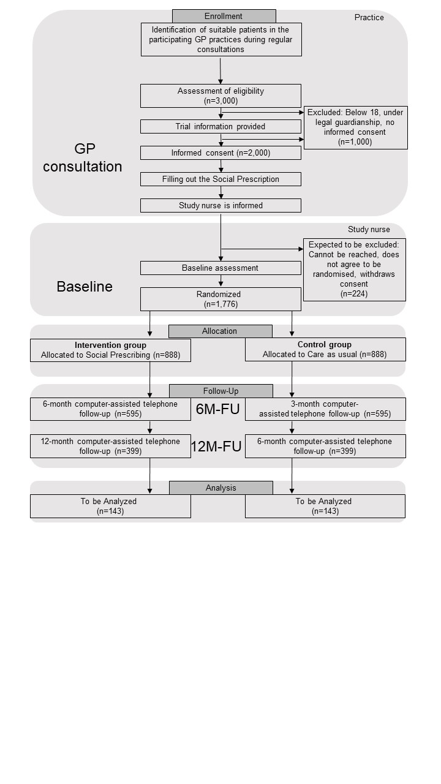
In the co-creation part, we will work together with representatives from each group of persons in vulnerable situations (i.e., a) LGBTIQ persons, b) refugees and first-generation immigrants and c) older adults living alone) to adapt social prescribing to their needs and social contexts. Three pioneer study hubs will focus on one of the vulnerable groups each, and the results from the pioneer hubs will be shared to inform all study hubs. Following the framework proposed by Hawkins et al, we will conduct an evidence review and consult key stakeholders along with representatives of each vulnerable group in the 1st phase of the co-creation process. In the 2nd phase, we will co-create the intervention of social prescribing (SP). In the 3rd phase, we will prototype the intervention with people of each group. This adapted intervention will be the basis for the following pragmatic RCT.
Consort Flow Diagram for the RCT
The pragmatic RCT is going to prove the effectiveness of an adapted social prescribing for a) LGBTIQ persons, b) refugees and first-generation immigrants and c) older adults living alone. To achieve this, we are going to conduct a basket trial, which consists of three independent sub-trials, one for each group. We will analyse the results of these sub-trials independently as an intention-to-treat analysis. Afterwards, we will pool the analysis through an individual patient data meta-analysis to report a joint outcome. The trial will be a multinational multicentre trial including 10 study hubs, each encompassing about 10 study centres (i.e. GP practices), in 8 different EU-countries (Spain, Iceland, Germany, Austria, Denmark, Switzerland, Poland, Croatia). For each sub-trial, we will recruit 600 patients from these 100 GP practices into the study. The primary outcome of the study is the access to health and care services, operationalized by the utilization of non-clinical supports and services within the community at 6-months-follow up. Secondary outcomes are health related quality of life, wellbeing, health care utilization, self-efficacy, health literacy, sick leave status and costs at 6-months-follow up and 12-months follow-up. We will develop a web-based open-source technical solution, which will enable link workers to store and share information on assets in the community which can be used in the broader implementation of SP afterwards.
In the qualitative comparative part, we are researching barriers and resources to implementing social prescribing by conducting qualitative interviews with stakeholders (e.g., patients, GPs, policy makers) in five different countries (UK, Germany, Portugal, Poland, Austria) representing different stages of the implementation of social prescribing and different forms of health care organization. We are going to conduct approximately 20 stakeholder interviews in each of the five countries and transcribe them verbatim. Framework analysis will be used to manage and interpret data. It was developed for qualitative research with relatively large samples and for undertaking analysis as a team. It will involve developing summaries (in a table-like chart) of what participants said in an interview, which can be shared with members of the research team. Framework analysis has the following stages: 1) Data management (familiarization, coding, indexing, charting) and 2) Abstraction and interpretation. Researchers employed on the project will be responsible for data management of a specific country/countries for which they will code data. These researchers will come together for regular meetings to compare and discuss coding with each other. Codes from across the countries will be used by the research team to develop a thematic framework to chart data against. Six charts will be produced. They will summarise data based on the same thematic framework, to help with identifying patterns and peculiarities across countries. Charts will be shared and discussed among the research team, to compare and contrast experiences and understanding of social prescribing among the countries involved. The results of the qualitative part will then help to prepare for the exploitation of the RCT results into health care policy and practice.
In a second phase of co-creation, the results mainly of the RCT but also of the qualitative comparative part are going to be interpret jointly by researchers involving also representatives of all three groups of persons in vulnerable situations. These jointly interpreted results will then be used to inform both, health and care practitioners, policy makers and the public about the results and deduce specific recommendations how to implement social prescribing for vulnerable groups in Europe.
Key facts of the RCT
Study design | International, multicentre, pragmatic, individually randomized, controlled basket trial
Population | Adults with at least one condition: |  | Non-Medical health related social needs (International Classification of Primary Care 3rd Edition, ICPC-3: ZC01-ZC99 “Social Problems”)
 | Belonging to one of three vulnerable groups: | LGBTI+ | Persons who self-identify at least as one out of this list: homosexual, lesbian, gay, pansexual, bisexual, trans, inter, non-binary
 |  | Refugees and first generation migrations | Persons who were born outside the EU
 |  | Older adults living alone | Persons at least 65 years old and living in a single-person household
Intervention | Social prescribing (GP issues social prescription, consultations with a link worker who connects the patient to local community services and offers); the intervention is adapted to each vulnerable group during the co-creation process (e.g., asset mapping, specific training for link workers and GPs)
Comparison | Care as usual
Outcome | Utilization of non-clinical supports and services within the community
Setting | Primary care (GP practices)
Time frame | Recruitment: 12 months  Intervention: 15 months intervention,  Follow up: 6 months (primary endpoint), 12 months  First patient in to last patient out: 28 months
Organization | 10 (academic) primary care research networks (Study hubs) in 8 countries with 10-12 GP practices each (study centres) recruiting 20 patients each
Basket trial design | Due to their heterogeneity, the three vulnerable groups serve as participants of independent sub-trials (cf. consort flow diagram). The management of the three sub-trials is streamlined (project management, data management, study personnel) to maximize resources. Study centres can decide for which sub-trials they want to recruit patients. Recruitment of study centres ensures recruitment goals for all sub-trials.
Sample size calculation | Preliminary sample size calculation (will be adjusted after co-creation process in year 1): Alpha two sided 0.05, Power 80%, Drop-out rate 33%, Improve probability of utilisation from .50 to .66 -> Sample Size per group 296; 592 to randomize per sub-trial; 1,776 over all sub-trials
Analyses | Using a statistical analysis plan (SAP):  1) Treatment policy estimand (Intention-to-treat) for the primary endpoint, individually for each sub-trial using a hierarchical mixed effects model including country, study hub and study centre (random effects) and treatment group (fixed effect)  2) Assessment of secondary and exploratory endpoints, such as health literacy and self-efficacy.  3) Subgroup analyses for factors, such as socio-economic and legal status, age, sex and gender identity, (dis)ability, ethnicity and geographical location, as well as vulnerability risks (e.g., XXX)  4) Pooling of effects in an individual participant data (IPD) meta-analysis  5) Cost-effectiveness analysis using primary data acquired through follow-ups

Relation of SP-EU to the six climate and environmental objectives (“EU Taxonomy”)
Social Prescribing contributes to climate chance mitigation as working and housing conditions as well as food security can be reasons for social prescribing. So called “green” social prescribing links people to nature-based activities, such as community gardening, mindful nature walks or volunteering in environmental organizations. There is evidence that SP results in the reduction of over-prescription that can help reduce carbon emissions as the manufacture and distribution of medicines, and the use of some medicines, has a significant impact on greenhouse gases. Additionally, SP-EU does not do any significant harm, it does not harm climate change adaption nor pollute water and marine resources; SP-EU does not influence the transition to a circular economy, influence pollution prevention and control nor harm biodiversity and ecosystems.
National or international research and innovation activities linked to SP-EU
There are national, European and international networks on social prescribing who work on education, policy and research in the field of social prescribing. SP-EU builds on the work conducted by these networks and tries to integrate them actively into the exploitation and dissemination of our results.
There are several national RCTs on social prescribing which are conducted or planned inside Europe and beyond. These trials have different target populations than ours, e.g., an Irish RCT is focusing on patients in primary care with polypharmacy. All these trials are only national trials not recruiting from more than one region or country. Thus, our project can build on the experiences of these trials but will go far beyond. PIs from these trials are partly consulted for SP-EU and are members of the external advisory board.
There are also trials and proposals regarding the vulnerable groups, we focus on. For example, we are aware of a proposal in this call focusing on trans persons’ health care. Our projects will complement each other in case of funding, and we agreed on serving in the advisory board of each other.
Inter-disciplinary approach: SP-EU represents a challenge, which can only be met in a multidisciplinary team. The consortium includes world leading family physicians, epidemiologists, social scientists, statisticians, public health specialists, and software developers. They work together achieving the overall vision of SP-EU. In each part of SP-EU, experts from these different areas are involved. Additionally, patients and citizens are integral part of the whole project thus widening the inter-disciplinary approach to a trans-disciplinary approach. To achieve this inter- and transdisciplinary collaboration, SP-EU can build upon established local, national, and international networks bringing these scientists and citizens together.
Integration of social sciences and humanities: Social sciences and humanities (SSH) are an integral part of SP-EU. The Co-creation process is led by researchers from SSH. The RCT is complemented by a process evaluation led by SSH. Finally, the qualitative comparative part is led and undertaken by scientists from SSH.
Gender Dimension: Sex, gender and an intersectional analysis are integrated in SP-EU. In the co-creation part, it is a core aspect to include citizens of all sex and genders and especially to include persons experiencing intersectionality. In the RCT part, we are going to assess variables such as gender, sexual orientation, migration background and socio-economic status, to assess the influence of sex, gender and intersectionality on the results of the trial. These analyses will be done as sensitivity and subgroup analyses. In the qualitative comparative part, we are going to balance the gender distribution of the stakeholder sample interviewed and ask specifically for sex, gender and intersectionality aspects regarding barriers and resources in implementing social prescribing.
Implementation of open science practices: As researchers, we have the responsibility to adopt processes that increase the likelihood that research is trustworthy, useful for scientists and society, and ethical for humans. We will employ a wide array of open science practices to ensure that these goals are met. While there is little reason to suggest publication bias in the field of Social Prescribing, reproducibility of and trustworthiness in the results have been suffering from missing open science practices, on which we will improve in SP-EU. The consortium is already actively involved in shaping open science practices, e.g., through research governance activities (Meta research).
Early and open sharing of research: We will actively work towards a culture of early and open sharing of our research. To achieve this goal, we will prospectively register all parts of SP-EU. We will publish protocols for all sub-trials, as well a Statistical Analysis Plan (SAP) for the sub-trials and meta-analysis. All results will be published as pre-prints to ensure timely access to the results. All data sets will be made available to the community before SP-EU ends.
Systematic research output management: To ensure easier access to valuable research resources and ensure the longevity of our scientific findings we will develop and implement strategies that facilitate the organization, documentation, and dissemination of research outputs, including data, software, and workflows. The software developed in the project will be published under open-source software licensing. This includes administration and support to ensure the sustainability of the software.
Measures to ensure reproducibility of research outputs: The project will be supported by innovative and comprehensive institutional initiatives to improve open science practices. This includes training of all researchers involved in the project through local, national, and international workshops. We will also integrate a “spoke and hub” model with the goal of strengthening the rigor, reproducibility, and transparency in biomedical research beyond the project. In the model, we will designate an “open science ambassador” who is specifically trained to provide resources to the rest of the research team to improve their knowledge, research methodologies, documentation, and data sharing practices.
Open access to research outputs: We will make all our research output accessible through immediate open access via a trusted repository under CC0. All information needed to validate or re-use the data will be provided as early as possible in the research process.
Early sharing of methods and participation in open peer-review: We will actively participate in open peer-review processes to foster transparency and accountability in the evaluation of research. In addition to favouring publication in journals with open identity and public reviews we will focus our attention on open participation where we will invite all relevant knowledge actors in the review process.
Involving all relevant knowledge actors including citizens, civil society and end users in the co-creation of R&I agendas and contents (such as citizen science): cf. Co-Creation, additionally: The project will also contribute to this goal through the integration and cooperation of many relevant stakeholders and the translation of the initiatives into the broader community. We will produce tailored information for all relevant actors. This includes adaptation to the vulnerable groups under consideration, as well as translation to all languages that are represented in the multinational consortium. There are no legitimate interests of the consortium (e.g., commercialization) that hinder sharing of research data, except for data safety reasons (e.g., sharing of pseudonymized data only).
Research data management and management of other research outputs
We will ensure high quality data management including the creation and recurrent updating of a joint data management plan (DMP). The DMP describes how we will handle data in accordance with the FAIR principles. We consider the DMP to be a “living document”, which needs to be updated on a regular basis to incorporate current insights and best practices. SP-EU will adhere to the FAIR principles as published by GO FAIR, as well as the Sorbonne declaration on research data rights. The focus will be on stimulating the adoption of common vocabularies and metadata schemes, and on more extensive sharing of data under unambiguous access conditions. We will work with the following data types, and address FAIR principles in the following ways:
Types of data/research outputs: We will make all relevant research outputs available. This includes data sets for the RCT (incl. code books and extensive metadata), data management and statistical analysis plans, code for the processing and analysis of the data sets, pre-prints, publications, external presentations and reports (e.g., policy briefings, tailored information for different stakeholders).
Findability of data/research outputs: F1. (Meta) data are assigned a globally unique and persistent identifier. F2. Data are described with rich metadata (defined by Reusability: R1 below). F3. Metadata clearly and explicitly include the identifier of the data it describes. F4. (Meta) data are registered or indexed in a searchable resource.
Accessibility of data/research outputs: A1. (Meta) data are retrievable by their identifier using a standardized communications protocol. A1.1 The protocol is open, free, and universally implementable. A1.2 The protocol allows for an authentication and authorization procedure, where necessary. A2. Metadata are accessible, even when the data are no longer available.
Interoperability of data/research outputs: I1. (Meta) data use a formal, accessible, shared, and broadly applicable language for knowledge representation. I2. (Meta) data use vocabularies that follow FAIR principles. I3. (Meta) data include qualified references to other (Meta) data.
Reusability of data/research outputs: R1. Meta (data) are richly described with a plurality of accurate and relevant attributes. R1.1. (Meta) data are released with a clear and accessible data usage license. R1.2. (Meta) data are associated with detailed provenance. R1.3. (Meta) data meet domain-relevant community standards. As evidence by F-UJI shows that R1 and R1.2 are currently underutilized, we will focus on these aspects.
Curation and storage/preservation costs: We will utilize the general-purpose repository for research data objects Zenodo. This repository is developed under the European OpenAIRE program and is funded by the European Commission. It is free-of-charge for users and there is a low risk for termination of the project. It provides features to adhere to all FAIR principles mentioned above and currently achieves the highest FAIRness score by F-UJI.
#§CON-MET-CM§# #§COM-PLE-CP§# #§REL-EVA-RE§#

Impact #@IMP-ACT-IA@#

Project’s pathways towards impact
Contribution of project results towards the expected outcomes and wider impacts
SP-EU will contribute to the goal creating a more resilient, inclusive and democratic European society of the Horizon Europe Strategic Plan 2021-2024 by addressing inequalities and providing high-quality health care. Thus, SP-EU contributes to the impact area “Good health and high-quality accessible healthcare”. Regarding the expected impacts in the area Ensuring access to innovative, sustainable and high-quality health care of cluster health, we will contribute especially to the following impacts:
I1) Health care systems provide equal access to innovative, sustainable and high-quality health care thanks to the development and uptake of safe, cost-effective and people-centred solutions, with a focus on population health, health systems resilience, as well as improved evidence-based health policies.
I2) The development of innovative solutions for health care systems in all their various dimensions and for policy-making
I3) New evidence, methods and tools to implement successfully those innovative solutions into their health care systems. It will deliver solutions that are scalable and transferrable between different types of health care systems in different countries and provide knowledge supporting the transfer of solutions between countries.
I4) Shifting from hospital-centred to community-based, people-centred and integrated health care structures
The following table shows, how we are going to achieve the expected outcomes described in the call:
Expected Outcome from the Call | How SP-EU achieves it
Decision- and policymakers, service providers, and health and care workers have better availability to and make use of knowledge on barriers to access to health and care services experienced by people in vulnerable situations and at risk of stigma or discrimination. | In the qualitative part as well as in the co-creation process we will focus on barriers to access for people in vulnerable situations. These barriers will be used in the design of the RCT as well as in the design of implementations strategies for SP. We will communicate the barriers to decision- and policymakers as well as services providers and health and care workers via different ways of communication and dissemination, e.g., workshops and social media.
Decision- and policymakers, providers and health and care workers have access to innovative solutions to promote and improve access to health and care services for people in vulnerable situations. | We will research the effectiveness of social prescribing as an innovative solution to promote and improve access to health and care services for people in vulnerable situations in the RCT. We will disseminate to decision- and policymakers as well as service providers and health and care workers continuously.
People in vulnerable situations are better equipped in terms of health and digital literacy, knowledge about their rights etc. when it comes to access to health and care services. | Social prescribing empowers persons in vulnerable situations. Thus, in subproject C, we will measure the effect of social prescribing on health and digital literacy and self-efficacy regarding access to health and care services.
People in vulnerable situations are involved in the design and implementation of research and innovation activities concerning access to health and care services. | We will involve people in vulnerable situation both in the design of SP specifically adapted for their needs and in the implementation of SP as a scalable intervention in European health care systems.
Building on these expected outcomes, we describe in the following, how we are going to achieve the expected impact I1-I4
Health care systems provide equal access to innovative, sustainable and high-quality health care thanks to the development and uptake of safe, cost-effective and people-centred solutions, with a focus on population health, health systems resilience, as well as improved evidence-based health policies (I1)
The exploitable results of SP-EU will inform policy makers of the evidence-base to implement SP in their health care systems. The innovative cornerstone of SP is to combine individual health care with population health. Due to the co-creation process, which we will conduct, the adapted SP will be people-centred. From the health economic analysis, we will know if SP is cost-effective. We will disseminate these results especially to policy makers in the field of health care. To improve the uptake of SP, we will publish short policy briefings containing the most important information on SP as well as manuals how to implement SP locally and countrywide. Thus, the results of SP-EU will enable policy makers to uptake SP as an innovative and sustainable solution for European health care systems to improve access to health related services in the community.
The development of innovative solutions for health care systems in all their various dimensions and for policy-making (I2)
We will bring SP forward to technology readiness level 9. Thus, we will develop SP further to be ready to be implemented by policy makers as an innovative solution.
New evidence, methods and tools to implement successfully those innovative solutions into their health care systems. It will deliver solutions that are scalable and transferrable between different types of health care systems in different countries and provide knowledge supporting the transfer of solutions between countries (I3)
From the qualitative part of SP-EU, we will report knowledge from different countries, which enables the transfer of SP between these countries in Europe. These qualitative results will improve scalability and transferability of SP.

Shifting from hospital-centred to community-based, people-centred and integrated health care structures (I4)
SP enables health care structures to strengthen the connection between health care and the community by introducing the link worker. Thus, it improves the resilience of community-based primary care by enabling to deal with health related social problems directly out of primary care and avoiding unnecessary hospital treatments. Because of the integrated co-creation, process our SP solution will be people centred. We will disseminate the results of SP-EU to all sorts of health care providers including manuals how to implement social prescribing on a local level as integrated health care structure.
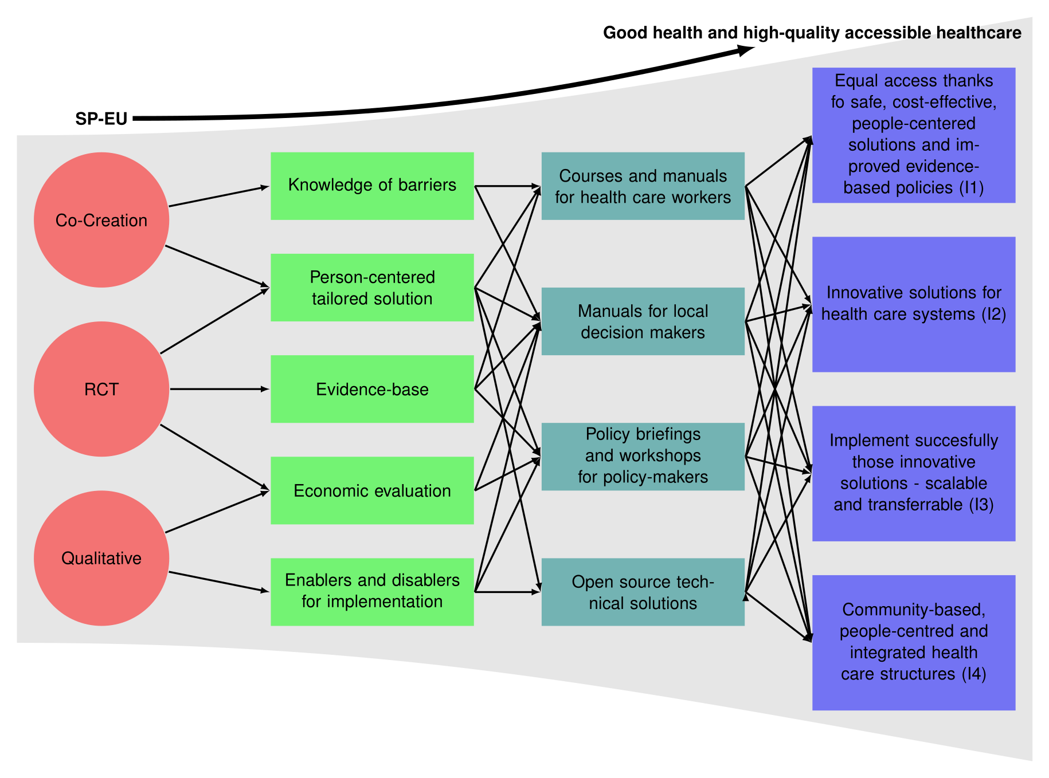

Scale and significance of the project's contribution to the expected outcomes and impacts
In the EU, there are about 20 million LGBT persons, more than 20 million refugees and displaced people and more than 20 million 1st generation immigrants, 40% of women 65 years of older in the EU live alone and 22% of mean 65 years adding up to more than 25 million older inhabitants living alone. These three vulnerable groups are thus of important scale for the European Union and social problems such as loneliness or financial problems are common and have a great impact on health and well-being.
With the results of SP-EU, we will be able to improve health and well-being for more than 60 million inhabitants of the EU by improving access to health and care services in the community. We will enable around 250.000 GPs in Europe to strengthen the community connections and provide better people-centred integrated health care for their patients with social prescribing.

Requirements and potential barriers
To achieve the impact of SP-EU on the health care systems, there are some potential barriers, which we are going to address:
Potential Barrier | How we address the barrier
Workforce considerations: There is a workforce shortage especially in the health and social care sector. Finding no link workers to implement social prescribing might be a barrier to implementing SP broadly in the EU. | The SP concept of SP-EU will free GPs from the burden of additional tasks with social problems. Thus, it will soften the workforce shortage of GPs.  The UK has already experiences in recruiting and training of Link Workers. We will learn from these experiences through the qualitative part of SP-EU as well as through setting up training and training manuals in the RCT. The lower entrance for link workers compared to nurses and social workers will ease the workforce shortage here.
Public acceptance: The public might not be willing to accept a referral from primary care to community services. | Experiences from the UK show a high acceptance of SP. However, we will address this barrier in the qualitative part of SP-EU and by having a good communication strategy involving social media and classic mass media in communicating with the public.
Financing: To implement SP, there will be two financial challenges. First financing the link worker and the process of social prescribing and second financing the community services. | We will address the issue of financing community services in the qualitative part of the study. There are going to be different local solutions in each of the EU states to cover these problems, as the community and NGO sectors are differently financed throughout the EU. With the data of the economic analysis from the RCT, we are going to be able to prove the financial sustainability of SP. We will start early in SP-EU communicating with policy makers on the financing of SP for vulnerable groups.

#§IMP-ACT-IA§#

Key Performance Indicator
Following the access model of Levesque, JF., Harris, M.F. & Russell, G. Patient-centred access to health care: conceptualising access at the interface of health systems and populations. Int J Equity Health 12, 18 (2013). https://doi.org/10.1186/1475-9276-12-18 and the SP definition of Muhl C, Mulligan K, Bayoumi I, et al Establishing internationally accepted conceptual and operational definitions of social prescribing through expert consensus: a Delphi study. BMJ Open 2023;13:e070184. doi: 10.1136/bmjopen-2022-070184
Spencer L et al. (2014) Analysis: Principles and processes. In: J Ritchie et al. (Eds) Qualitative research practice (2nd Ed). Sage: London.

